Lakshmi Durga Puppala

Information Technology Field Experience – EX30

Cumberland University

June 29th, 2025

**Progress Report for Milestone 1**

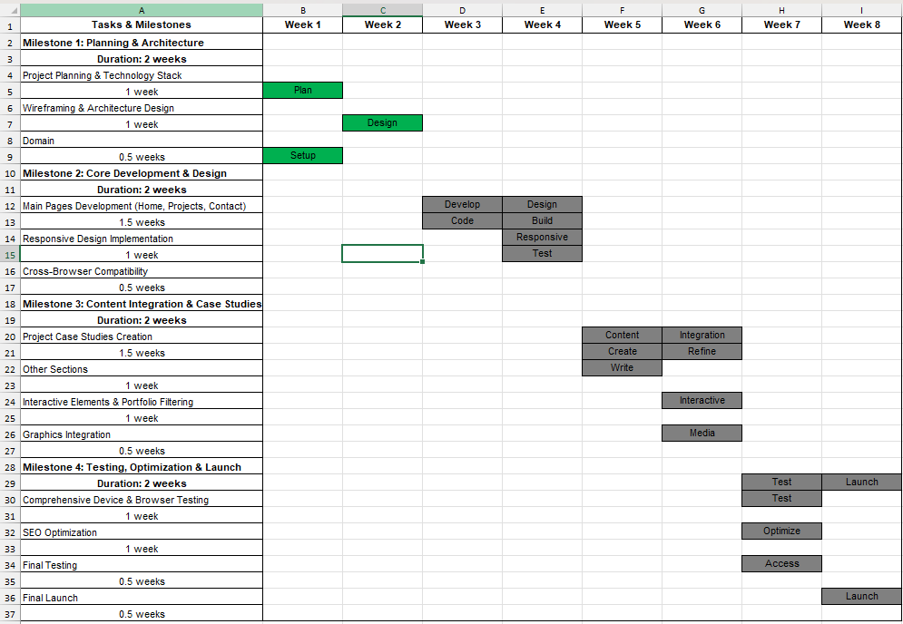**Below is the updated Gantt Chart after Milestone 1:**

|  |  |
| --- | --- |
| Completed - Finished Tasks |  |
| In Progress - Currently working |  |
| Not Started - Pending Tasks |  |

**A. What was our Milestone and subtasks?**

The first main goal was to finish the Planning & Design for the website. This was an important first step to create a clear and solid plan for the entire project. The smaller tasks for this goal included deciding on the website's structure, drawing simple sketches of each page, gathering all the necessary text and photos and choosing the colors and fonts for the design.

**B. Were I successful or not? Why or why not?**

Yes, this milestone was completed very successfully. I managed to finish all the planned tasks right on schedule, thanks to careful time management and a clear focus. There were no delays and because I stayed organized, I was able to transition smoothly into the next phase of the project. I now have a strong and complete plan to guide us as I start building the website.

**C. What did I learn from the past 2 weeks?**

From this phase, I learned that dedicating time to detailed planning at the beginning is incredibly valuable, as it prevents confusion and saves a lot of time later on. Having the design sketches and a clear structure before writing code gives us a confident and clear guide to follow, ensuring the development process is smooth. I have also recognized the importance of organizing all content early, which was a key factor in helping us stick to the schedule.

**D. What is our next Milestone, subtasks and deadline?**

Next main goal is the Core Development and Design. This means I will now start the exciting work of building the actual website. The smaller tasks for this phase are setting up the computer and tools for coding, writing the basic HTML and CSS code, building the Home, Projects and Contact pages and adding simple JavaScript to make the website interactive. The deadline for this milestone is July 13, 2025.

**E. What do I need to do in our own time to make sure that I are successful?**

To ensure I succeed in the next development phase, I will maintain focused and disciplined approach. Following the Gantt chart schedule closely will continue to be the top priority. I will also dedicate personal time to practicing and improving my coding skills, which will help ensure the website is built to a high standard and works perfectly on all devices. To keep the project organized and track all progress, I will continue to save my work to GitHub daily, which is an excellent habit for any developer.